**Multi Purpose Application**

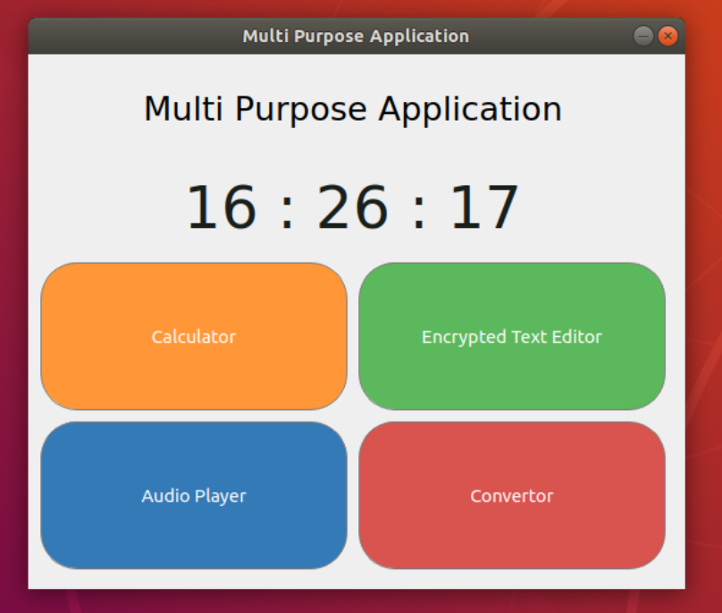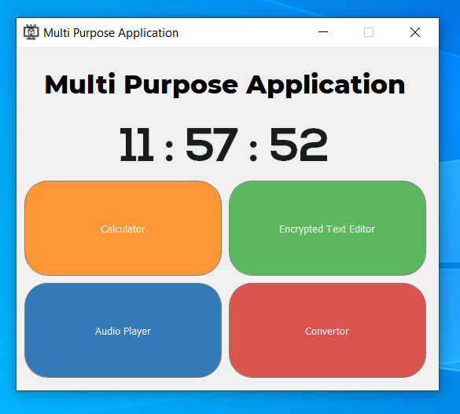

This is a multi purpose application. It has 4 applications. They are Calculator, Encrypted Text Editor, Audio Player and Binary to Decimal Converter. And here displays the **current time**.

**Encrypted Text Editor**

This is the Encrypted Text Editor. This is the main target of the project. Using this you can encrypt and decrypt any text. It asks for a key and encrypt the text associated with that key. In here you can save, open, cut, copy and paste a file. You can change font style, font color, but it does not apply to encrypt. As well as there has undo and redo and print facility also.

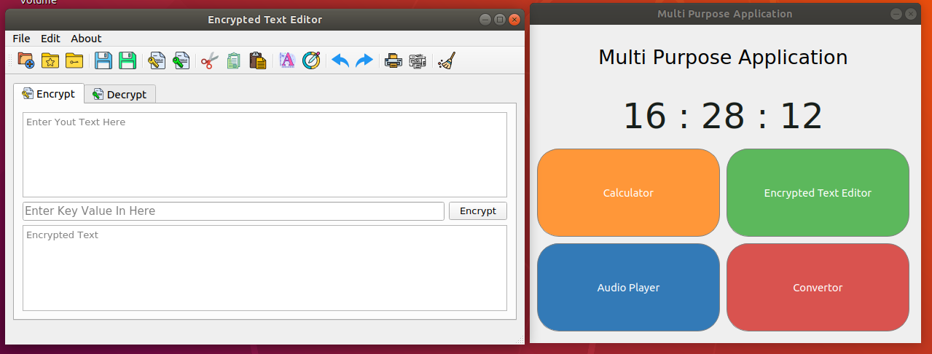**Specially in here I used Responsive and User Friendly UI**

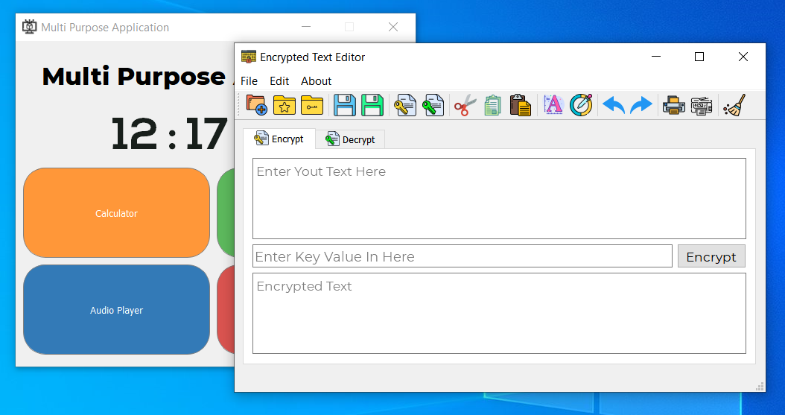

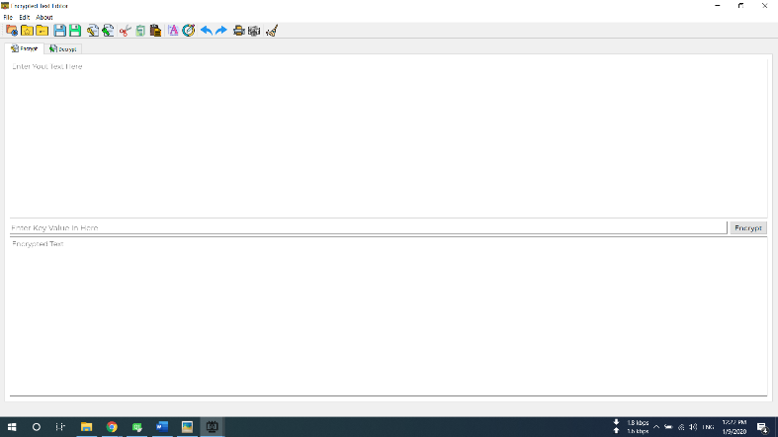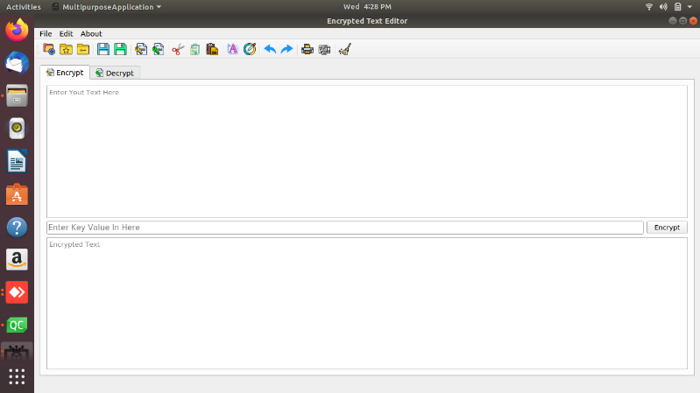

*This is the Full Screen and responsive view*

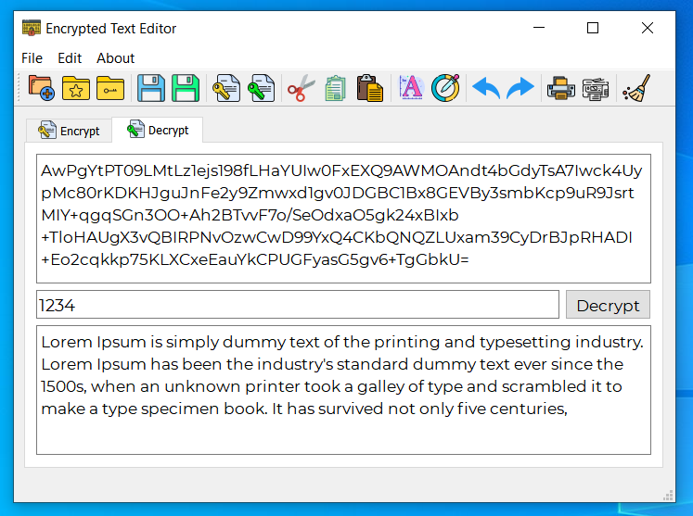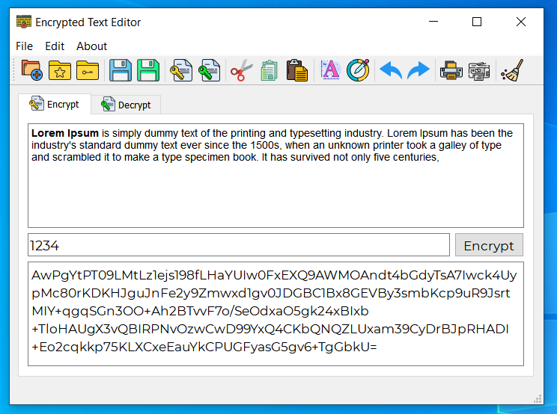

*Decryption*

*Encryption*

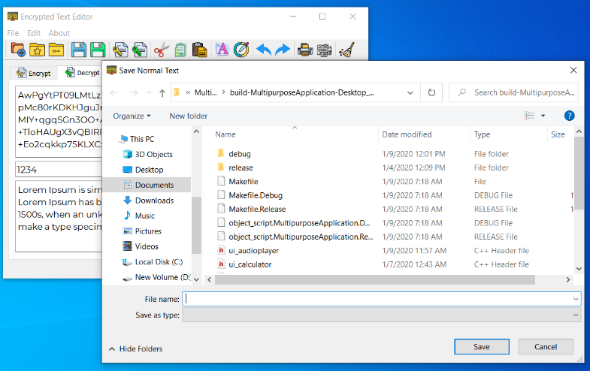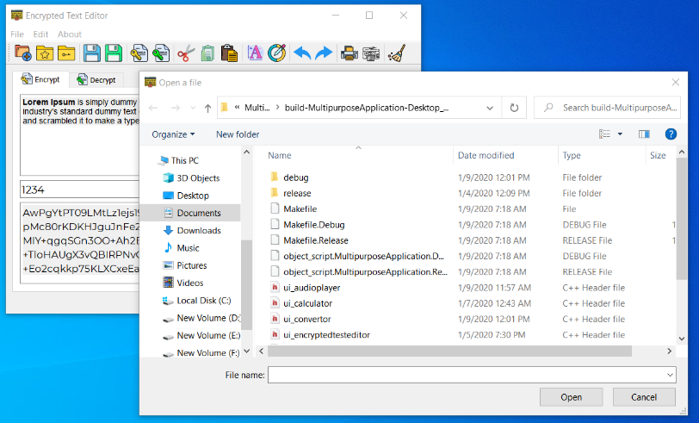

*Save text files*

*Open text files*

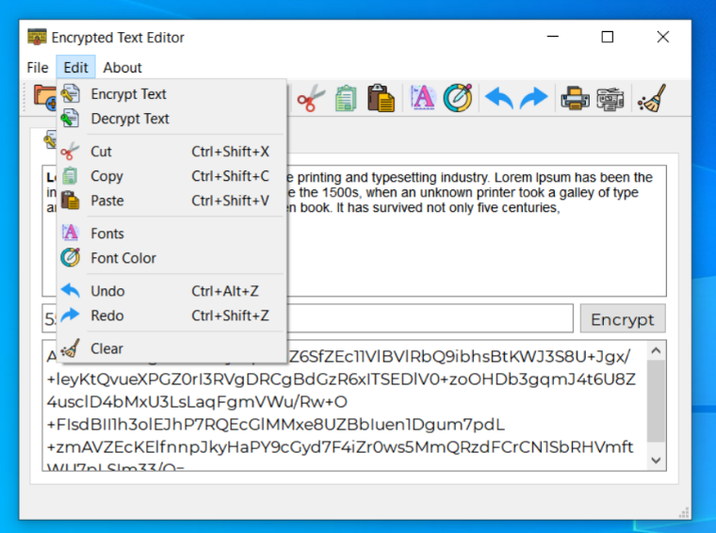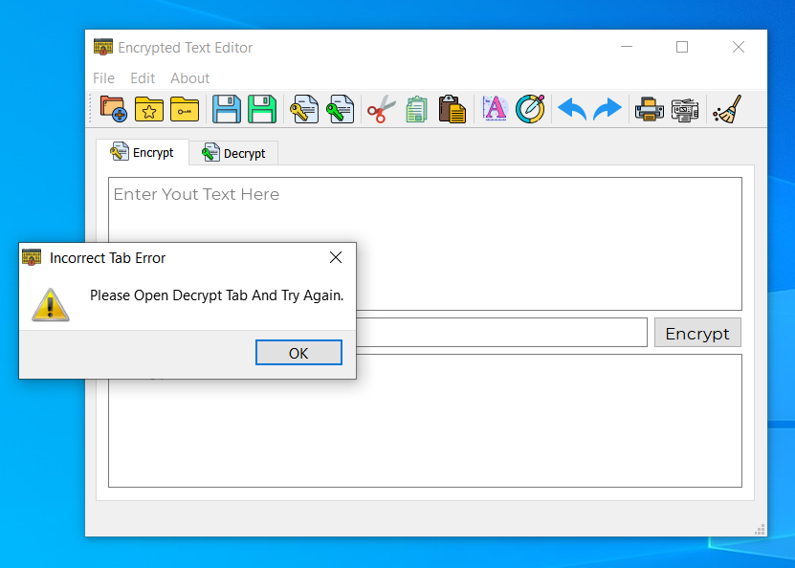

*Menus*

*Error handling*

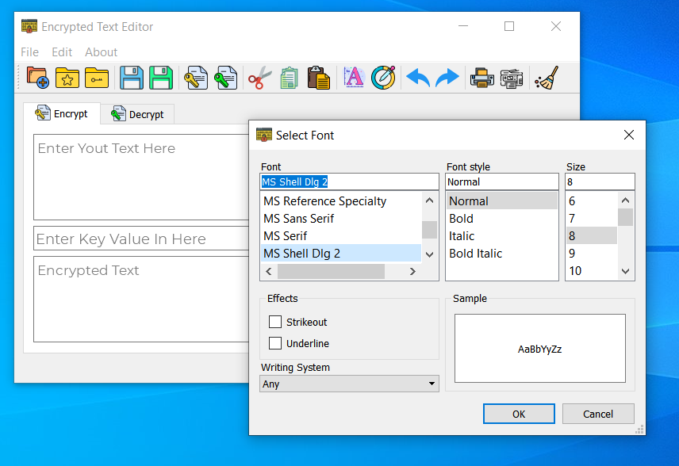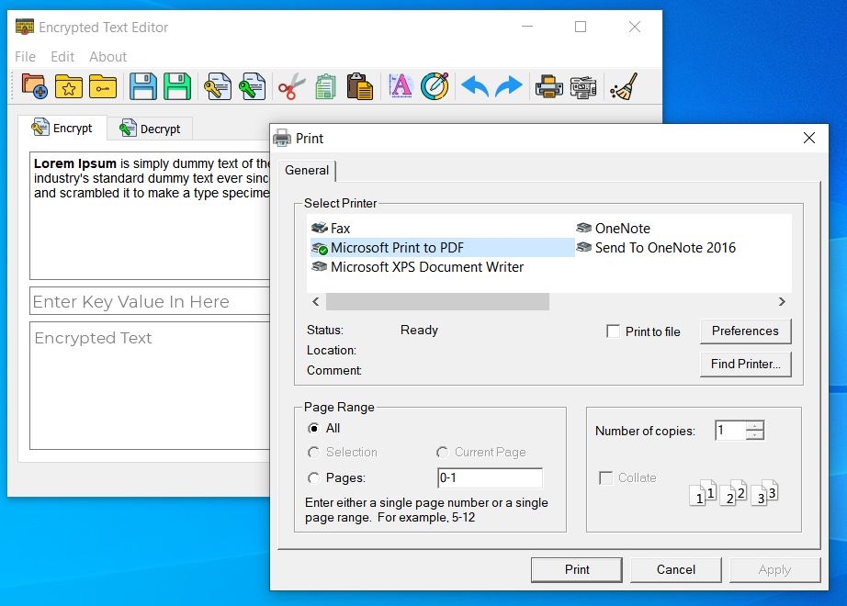

*Font Change*

*Print Function*

**Calculator**

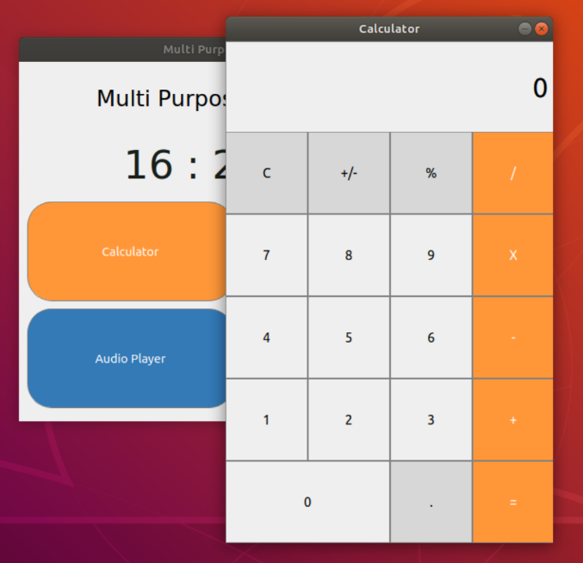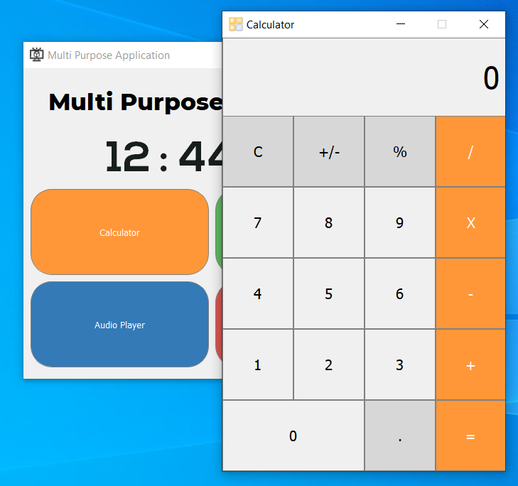 This is the Calculator. You can use this function to add, subtract, multiply and divide.

**Audio Player**

This is an audio player. You can listen to any audio using this.

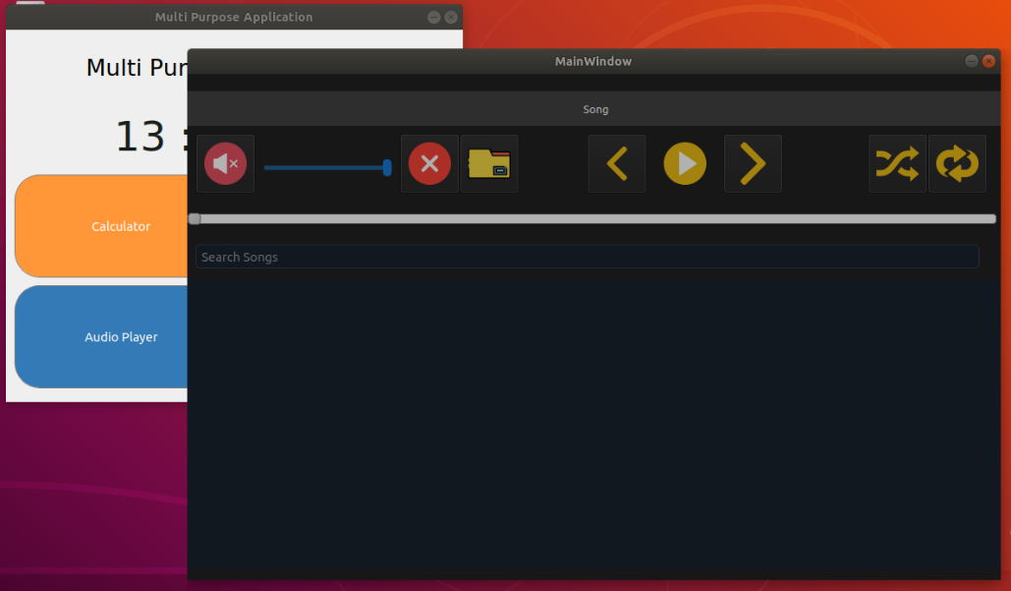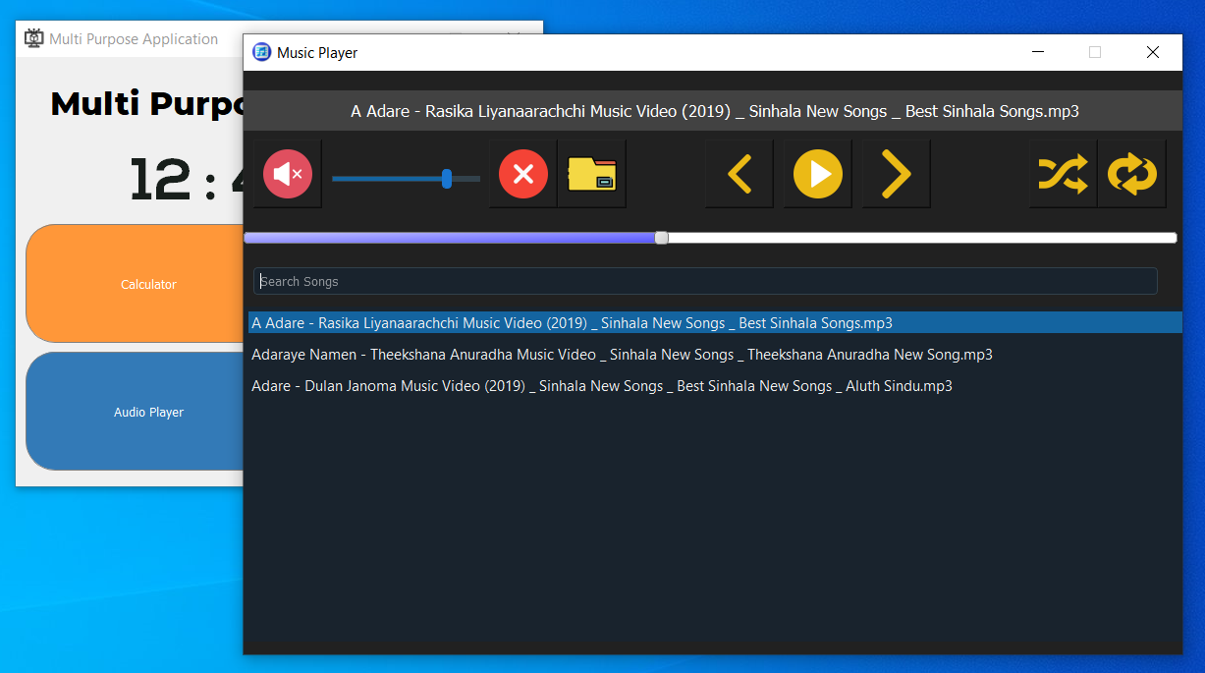

**Binary to Decimal Convertor**

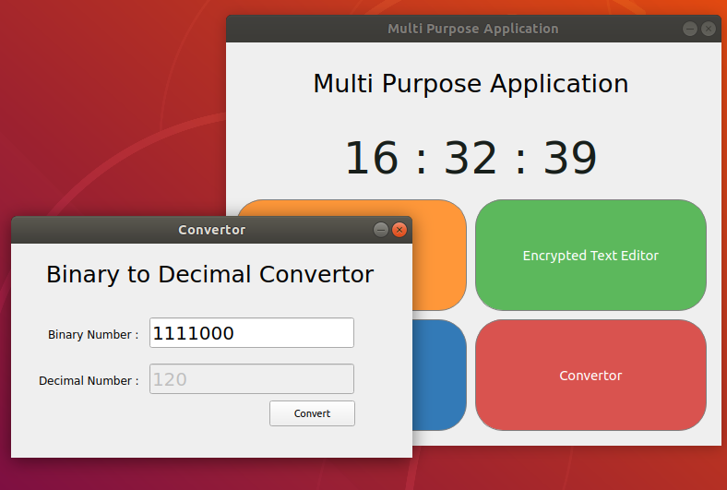This is the Converter application. You can use this to convert binary numbers to decimal numbers, and decimal numbers into binary numbers